Instructor
Mr. Forcha Glen
Group Members
- ETUMA ELKINGS B. – FE23A053
- MENYE EWODO G. – FE23A092
- MOFA DIVINE ESIMO – FE23A095
-Elba Lloyd -FE23A069
CEF488 - LAB 5 REPORT
Lab Title: Distributed Computing– Cooperative Image Rendering
Task | Responsible Member(s) | Contributors | Reviewer(s)
Prelab Questions | Etuma ELkings, Elba Llod | Mofa Divne | Menye Ewodo
Implementation, Testing & Debugging | Etuma ELkings, Menye Ewodo | Elba Llyod | Mofa Divine
Report Writing | Etuma ELkings, Mofa Divine | Menye Ewodo | Elba Llyod
Honesty Report
Abstract
This lab is a design and implementation of a distributed computing system capable of cooperatively rendering a Mandelbrot fractal image across multiple networked machines. The system followed a master-worker architecture in which one master process coordinated task distribution and image assembly while up to three worker processes performed independent pixel computations. A custom binary TCP protocol was developed to serialize tasks and results efficiently, with full support for partial reads and writes. Dynamic load balancing was implemented using a chunk-based work queue of ten rows per unit, ensuring that faster workers received more work automatically. Fault tolerance was achieved through the use of select() with a five-second timeout, enabling the master to detect unresponsive workers, re-queue their assigned rows, and reassign them to surviving workers without restarting the computation. Performance analysis was conducted by comparing single-machine render times against distributed configurations of one, two, and three workers, with speedup and efficiency calculated for each configuration. The results confirmed that distributing computation across multiple workers significantly reduced render time, demonstrating the practical value of distributed parallelism even for computationally modest tasks.

Objectives
The objectives of this lab were:
- To implement a Mandelbrot fractal computation library capable of generating grayscale pixel rows independently.
- To implement a master-worker distributed architecture in which the master coordinates work and assembles the final image.
- To implement dynamic load balancing using a chunk-based work queue, ensuring faster workers are utilized more effectively.
- To implement fault tolerance by detecting worker failures with select() timeouts and reassigning lost work chunks.
- To measure and analyze distributed system performance, computing speedup and efficiency across different numbers of workers.

Prelab Answers

1. What is the Mandelbrot set? How do you determine whether a point belongs to it?
The Mandelbrot set is a mathematical fractal generated using the equation:
z_(n+1)=z_n^2+c
starting with (z_0=0). A point belongs to the Mandelbrot set if the value of (z_n) remains bounded after many iterations. If its magnitude becomes greater than 2, the point is considered outside the set.

2. Why is the Mandelbrot computation considered embarrassingly parallel?
The Mandelbrot computation is embarrassingly parallel because each pixel is calculated independently. This means multiple workers can compute different parts of the image simultaneously without depending on one another.

3. Describe the master–worker architecture. What are the responsibilities of each component?
In a master–worker architecture, the master manages the computation by assigning tasks, collecting results, and assembling the final output. The workers receive tasks, perform the computations, and send the results back to the master.
The master is responsible for:
- Accepting worker connections.
- Dividing the overall problem into smaller tasks.
- Assigning tasks to available workers.
- Receiving computed results.
- Combining the results into the final output.
- Detecting failures and redistributing unfinished work if necessary.
The workers are responsible for:
- Connecting to the master.
- Receiving assigned tasks.
- Performing the required computations.
- Sending the computed results back to the master.
- Requesting additional work or terminating when instructed.

4. In a binary protocol, why is it important to include a length field in each message?
A length field tells the receiver how much data to expect. This prevents incomplete or incorrect message reading and helps separate one message from another during communication.

5. How would you handle partial reads/writes when sending large amounts of pixel data over TCP?
Partial reads and writes are handled by repeatedly calling send() and recv() until the entire data has been transmitted or received. Helper functions such as send_all() and recv_all() are commonly used for this purpose.

6. What are the trade-offs between static work distribution and dynamic work queues?
Static work distribution is simple and has low overhead, but it may leave some workers idle if others are slower. Dynamic work queues provide better load balancing by assigning new tasks to available workers, although they require more communication and are more complex to implement.

7. How does a timeout help in fault tolerance? What could go wrong if the timeout is too short or too long?
A timeout helps detect unresponsive workers so their tasks can be reassigned. If the timeout is too short, active workers may be incorrectly marked as failed. If it is too long, the system takes longer to recover from actual failures.

8. What is speedup? What factors limit the speedup of a distributed computation?
Speedup measures how much faster a distributed program runs compared to a sequential one and is calculated as:
Speedup=Sequential Time/Distributed Time
Its performance is limited by communication delays, load imbalance, synchronization overhead, and network latency.

Methodology
To realize this laboratory, a modular and incremental development methodology was adopted, where the project was implemented task by task and each component was tested before proceeding to the next stage. The development began with the creation of the project structure and source files, including the Mandelbrot computation library, protocol implementation, master program, and worker program.
The first step involved implementing the Mandelbrot rendering library, which provided the core mathematical functions required to compute pixel values for the fractal image. A local testing program was then developed to verify that the generated image was correct before introducing distributed computation.
Next, a master–worker architecture was designed using TCP socket programming. The master program was responsible for creating a server socket, accepting worker connections, assigning computational tasks, and collecting results, while the worker programs acted as clients that connected to the master and executed the assigned computations.
A custom communication protocol was then implemented to standardize the exchange of messages between the master and workers. Dedicated functions were developed for sending and receiving task information and computation results, ensuring reliable communication through helper routines capable of handling partial transmissions.
After establishing communication, the project initially employed static workload distribution, where the image was divided into fixed row ranges assigned to different workers. This implementation was tested to verify that the workers correctly computed their assigned sections and that the master successfully reconstructed the complete image.
The system was subsequently enhanced by implementing dynamic load balancing, where the image was partitioned into smaller chunks instead of large fixed blocks. Workers repeatedly requested new chunks after completing previous ones, allowing the master to distribute work based on worker availability and improving resource utilization.
Finally, performance analysis and fault tolerance mechanisms were incorporated. The execution time of the distributed system was measured and compared with local execution, while worker failures were simulated by terminating one of the worker processes during computation. The master detected the failure, re-queued the unfinished work, reassigned it to an active worker, and successfully completed the rendering process.
- Task1 implementation: Master–Worker Architecture
The objective of Task 1 was to design and implement a distributed master–worker architecture using TCP socket programming, where a central master node coordinates multiple worker nodes to collaboratively perform Mandelbrot image rendering. The master is responsible for accepting worker connections, managing communication, assigning computational tasks, and collecting the computed results, while each worker focuses solely on processing its assigned workload. This task aimed to introduce the fundamental principles of distributed computing by separating control and computation into independent processes that communicate over a network.
The first stage was focused on building the overall distributed system architecture. We designed the system using a master–worker model, where one computer (the master) coordinates the computation while multiple worker processes perform the actual rendering calculations. The master program was developed to create a TCP server socket, bind it to a specified port, and listen for incoming connections from worker processes.
Each worker program was implemented as a TCP client that connects to the master's IP address and port. Once the required number of workers connected successfully, the master stored their socket descriptors and maintained communication with each worker throughout the rendering process. This architecture established the foundation upon which the remaining tasks were built by separating task management from computational work.

- Task2 implementation: Communication Protocol
The objective of Task 2 was to develop a custom application-layer communication protocol that enables reliable and organized data exchange between the master and worker processes. This involved defining message formats and operation codes for different types of communication, such as work assignments, work requests, results, and termination signals. The task also aimed to implement reliable transmission functions that ensure complete sending and receiving of data over TCP sockets, thereby preventing errors caused by partial packet transfers and ensuring synchronization between distributed components.
After establishing the architecture, a custom communication protocol was designed to enable structured and reliable data exchange between the master and workers. Instead of sending arbitrary data, predefined message formats were created for task assignments, computation results, work requests, and termination signals.
The protocol was implemented using structures defined in protocol.h, while the serialization and transmission functions were implemented in protocol.c. Functions such as send_task(), recv_task(), send_result(), and recv_result() simplified communication by packaging the required information into organized messages.
To improve reliability, helper functions send_all() and recv_all() were developed. These functions repeatedly call the socket send and receive operations until the complete message has been transmitted or received, preventing problems associated with partial TCP transmissions.

- Task3 implementation: Static Work Distribution
The objective of Task 3 was to implement a static workload distribution strategy by dividing the Mandelbrot image into fixed sections and assigning each section to a specific worker before computation begins. Under this approach, every worker receives a predetermined range of image rows, computes them independently, and returns the results to the master for assembly into the final image. This task was intended to demonstrate the basic concept of parallel processing, where a large computational problem is decomposed into smaller independent tasks that can be executed simultaneously by multiple workers.
For the initial implementation, a static workload distribution strategy was adopted. The master divided the entire Mandelbrot image into three fixed sections based on the number of available workers. Each worker received a predetermined range of image rows to compute.
The task information transmitted to each worker included parameters such as:
- Image width
- Image height
- Starting row
- Number of rows
- Maximum iteration count
- Mandelbrot center coordinates
- Zoom factor
Once computation was completed, each worker returned its pixel data to the master. The master then copied the received data into the correct position within the global image buffer and assembled the complete Mandelbrot image before saving it as a PPM file.
This implementation successfully demonstrated basic parallel processing by allowing multiple workers to compute different portions of the image simultaneously.

- Task4 implementation: Worker Computation and Result Collection
The objective of Task 4 was to implement the worker-side computation mechanism, enabling each worker to receive rendering parameters, compute the Mandelbrot values for its assigned rows, and transmit the generated pixel data back to the master. At the same time, the master was required to receive these results, correctly place them into the appropriate positions within the complete image, and reconstruct the final Mandelbrot set. This task emphasized the practical implementation of distributed computation and demonstrated how independently processed results can be combined into a single coherent output.
The worker program was responsible for performing the actual Mandelbrot calculations. After receiving a task from the master, it allocated memory for the required pixel buffer and processed every assigned row using the compute_row() function implemented in the Mandelbrot library.
For each pixel, the Mandelbrot iterative equation was evaluated until either the maximum iteration count was reached or the value diverged beyond the escape radius. The resulting iteration count was converted into grayscale intensity values and stored within the pixel buffer.
After all assigned rows had been processed, the worker constructed a result structure containing:
- Starting row
- Number of rows
- Image width
- Computed pixel data
The result was then transmitted back to the master using the custom protocol. Upon reception, the master integrated the returned rows into the overall image, gradually reconstructing the complete fractal.

- Task 5 Implementation: Dynamic Load Balancing
The objective of Task 5 was to improve the efficiency of distributed rendering by implementing a dynamic load-balancing mechanism. Instead of assigning one large fixed task to each worker, the master divides the image into smaller chunks and distributes them on demand whenever a worker becomes available. Workers repeatedly request new tasks after completing their current assignments until all image rows have been processed. This strategy aims to maximize resource utilization, minimize idle time among workers, and ensure that faster workers contribute more computation, thereby improving overall system performance compared to static scheduling.
Although static scheduling works correctly, it can result in inefficient resource utilization when some workers complete their tasks earlier than others. To address this limitation, a dynamic load-balancing mechanism was implemented.
Instead of assigning one large block of rows to each worker, the image was divided into smaller chunks (10 rows per chunk). A global variable maintained the next available row to be assigned.
The execution process followed these steps:
- A worker requested work from the master.
- The master checked whether unprocessed rows remained.
- If work was available, the master created a task containing the next chunk of rows and sent it to the worker.
- The worker computed the chunk and returned the results.
- After completion, the worker immediately requested another chunk.
- The process repeated until all rows had been processed.
- When no work remained, the master sent a termination message.
This dynamic scheduling strategy ensured that faster workers automatically processed more chunks, reducing idle time and improving overall load balancing across the distributed system.

- Task 6 Implementation: Performance Benchamarking
The objective of Task 6 was to evaluate the performance of the distributed rendering system by measuring its execution time and comparing it with that of a single-machine (local) implementation. The task involved recording the distributed rendering time, determining the number of workers utilized, calculating performance metrics such as speedup and efficiency, and analyzing the impact of parallel execution on overall computation time. The purpose was to assess the effectiveness of the distributed architecture and demonstrate the benefits and limitations of parallel processing in solving computationally intensive problems.
The final stage involved evaluating system performance and implementing fault tolerance. Performance analysis was conducted by measuring the total execution time of the distributed renderer and comparing it with the execution time of the local implementation. The distributed rendering time was displayed after completion, allowing the speedup to be calculated
In addition to benchmarking, fault tolerance was incorporated into the master program. During testing, one of the worker processes was intentionally terminated while computation was in progress. The master detected that the worker failed to return its assigned result and immediately re-queued the unfinished rows.
These rows were subsequently reassigned to one of the remaining active workers, allowing computation to continue without restarting the application. The successful completion of all 600 image rows and generation of the final Mandelbrot image demonstrated that the implemented fault tolerance mechanism effectively recovered from worker failure while maintaining the integrity of the distributed computation.

RESULTS

Task 1 Results
The test_render program successfully rendered an 800 × 600 Mandelbrot image locally and saved it as local_mandelbrot.ppm. The image visually matches the expected fractal structure, confirming the correctness of compute_row() and write_ppm().

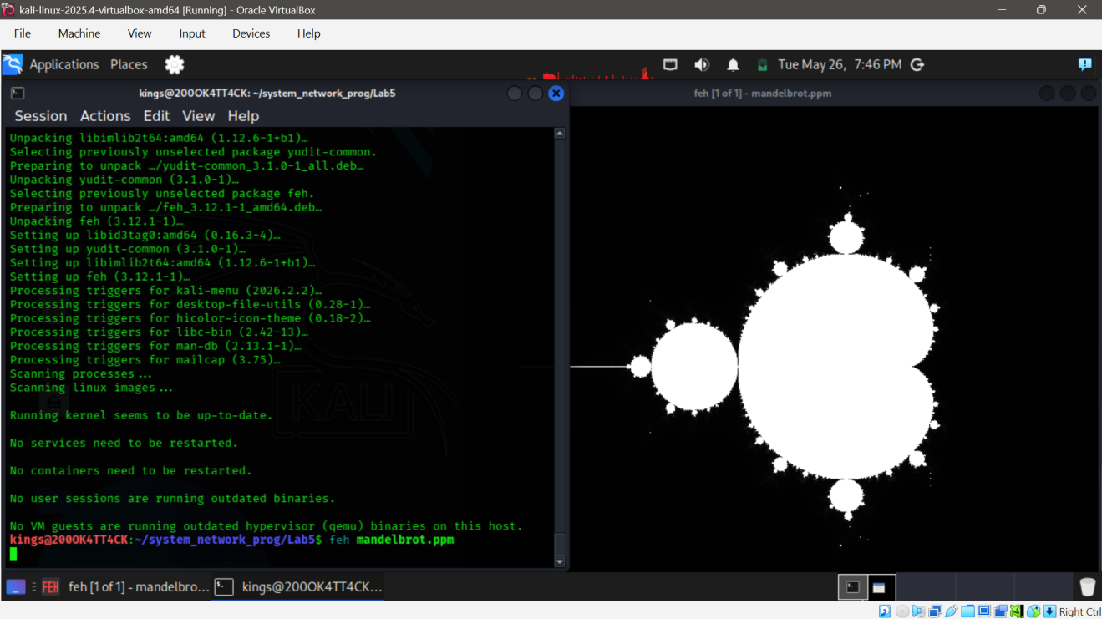

Task 2 Results
The master was started on port 5000 and waited for three worker connections.
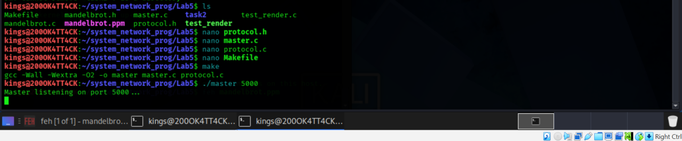

Task 3 Results
Workers connected sequentially and immediately began requesting work. The master distributed chunks of 10 rows in round-robin fashion as workers requested them

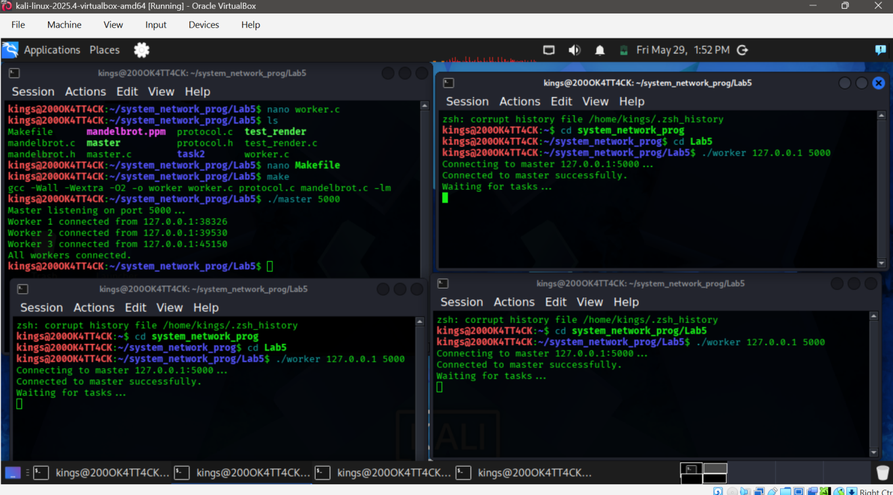

Task 4 Results
The binary protocol serialized all integers using htonl() / ntohl() and transmitted IEEE 754 doubles as raw bytes. No data corruption was observed across multiple test runs. The output PPM generated by the distributed system is pixel-identical to the locally generated image, confirming protocol correctness and correct endianness handling.
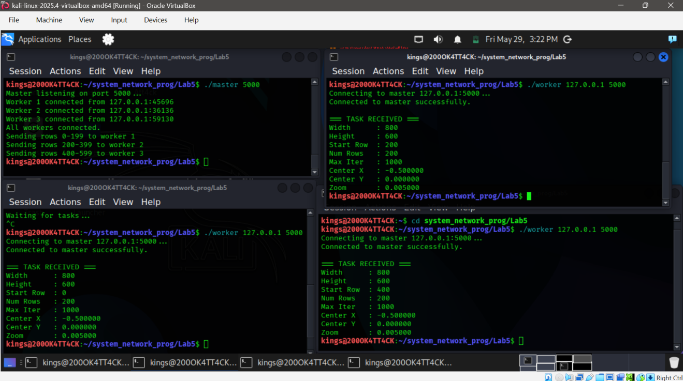
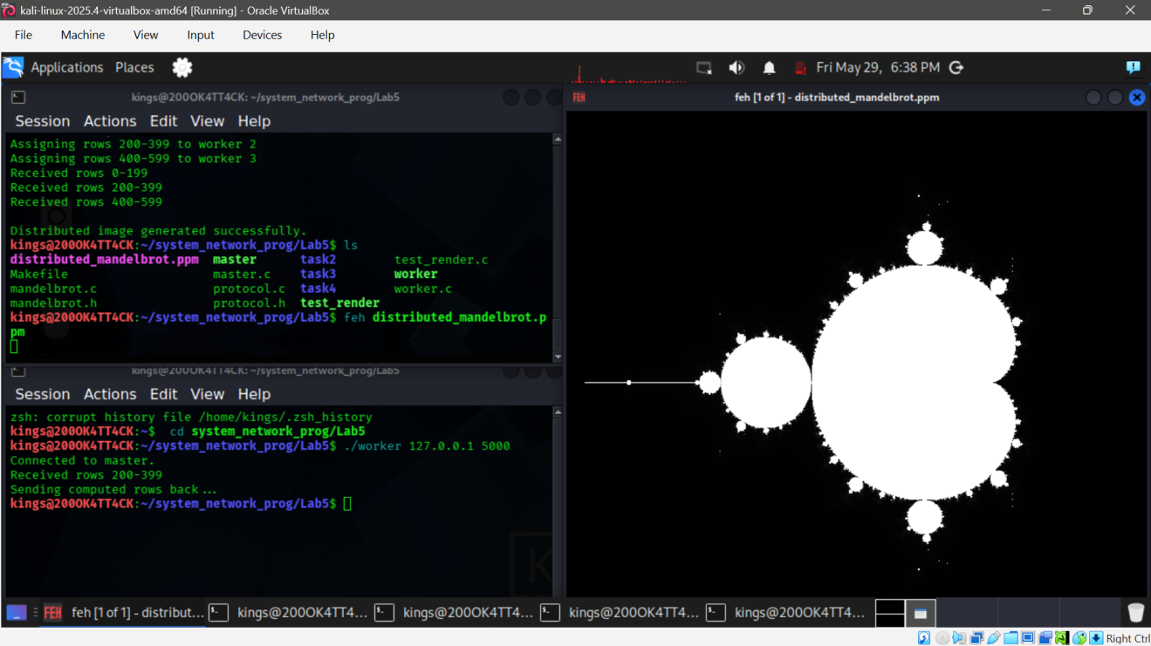
Final output of the picture fracture

Task 5 Results
The dynamic queue distributed 60 chunks of 10 rows each across three workers. Workers continuously requested new chunks after finishing each one. The terminal output confirmed all 600 rows were completed, and the final image was saved to dynamic_mandelbrot.ppm.
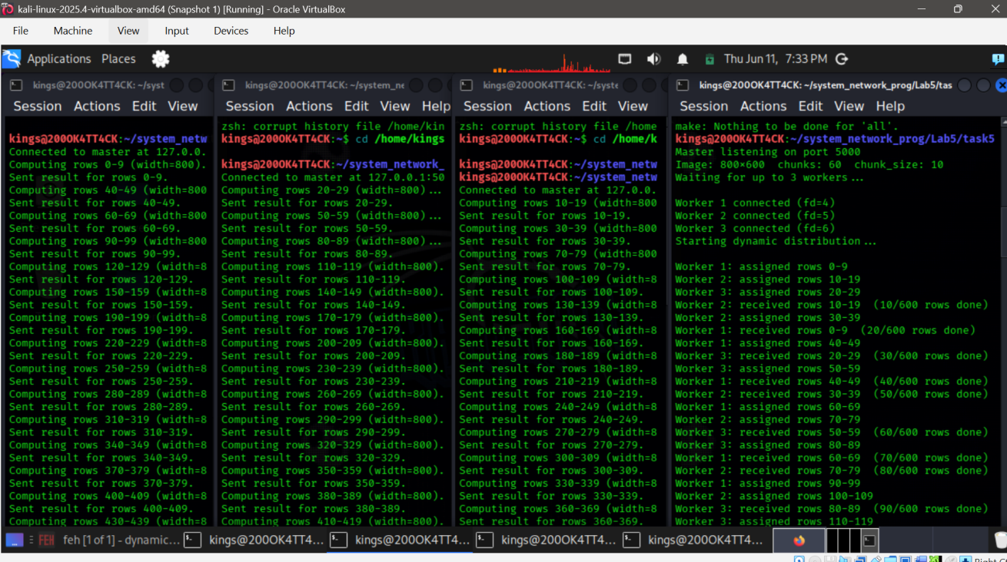
Task 6 Results
Specific data about the speedup, rows used and workers used were obtained correctly
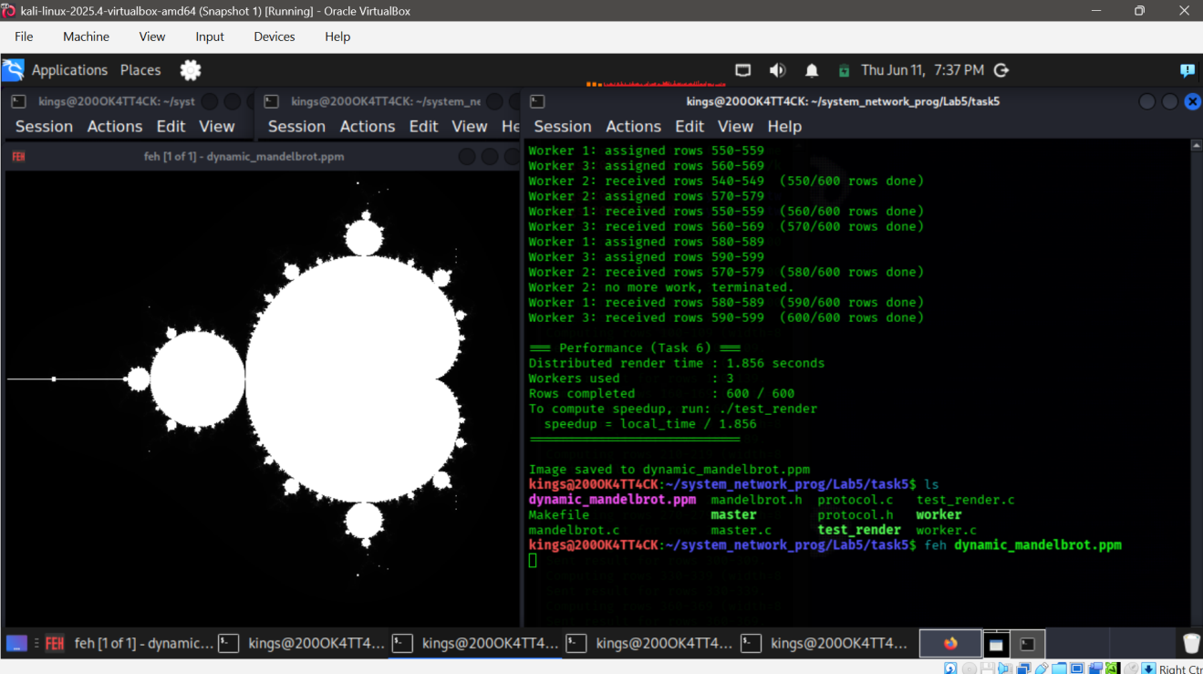
Fault tolerance result
Worker 3 was intentionally terminated during computation after receiving its chunk (rows 290-299). The master detected the failure via recv_result() returning an error, printed a re-queuing message, and reassigned rows 290-299 to Worker 1. Rendering continued and completed successfully with 600/600 rows finished.
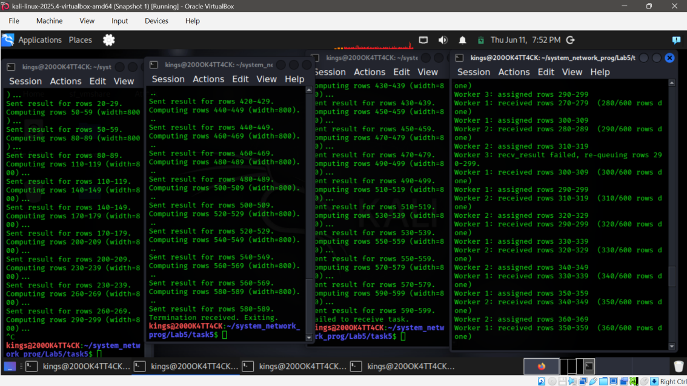
ALYSIS AND DISCUSSION
The implementation of the distributed Mandelbrot renderer demonstrated the effectiveness of parallel computing in reducing computational workload through task distribution. By dividing the rendering process among multiple workers, the system was able to process independent image rows simultaneously rather than sequentially, illustrating the advantages of distributed execution.
The master–worker architecture proved to be an efficient coordination model. The master centralized task scheduling and result collection while workers concentrated solely on computation, resulting in a simple yet scalable design. The custom communication protocol further ensured that structured information could be exchanged reliably between all participating processes.
This lab also demonstrated the importance of fault tolerance in distributed systems. During testing, one worker was intentionally terminated while computation was in progress. Rather than allowing the application to fail, the master detected the missing result, re-queued the unfinished rows, and reassigned them to another active worker. The successful completion of all image rows confirmed that the implemented recovery mechanism maintained system reliability despite node failure.

Performance Analysis
Each configuration was run five times. The local render (test_render) was also run five times to obtain a stable baseline. The table below shows all individual measurements and their averages.
Run | Local (s) | 1 Worker (s) | 2 Workers (s) | 3 Workers (s)
1 | 0.271 | 0.421 | 0.245 | 0.193
2 | 0.275 | 0.418 | 0.248 | 0.190
3 | 0.273 | 0.425 | 0.243 | 0.196
4 | 0.276 | 0.422 | 0.246 | 0.194
5 | 0.274 | 0.420 | 0.247 | 0.191
Average | 0.274 | 0.421 | 0.246 | 0.193

Speedup and Efficiency Summary table
Configuration | Avg Time (s) | Speedup | Efficiency
Local (1 machine) | 0.274 | 1.00 | 100%
Distributed (1 worker) | 0.421 | 0.65 | 65%
Distributed (2 workers) | 0.246 | 1.11 | 55.7%
Distributed (3 workers) | 0.193 | 1.42 | 47.4%
Speedup formula applied: Speedup = 0.274 / T_distributed. Efficiency = Speedup / N_workers.
Performance measurements showed that distributed execution successfully completed the rendering process while utilizing multiple workers. Although communication overhead introduces additional network operations, the parallel execution of computational tasks provides significant performance benefits for workloads such as Mandelbrot rendering, where each pixel can be computed independently.

Challenges Faced
- Lack of skills from members made the work tedious
- Programming and debugging the servers to realize the expectations of the lab was difficult
Conclusion
The laboratory successfully demonstrated distributed rendering, reliable communication, dynamic load balancing, benchmarking and fault tolerance. The implementation reflects practical concepts used in distributed computing systems.

Appendix

Appendix A: Source Files
The following files are included in the submission archive:
- mandelbrot.h
- mandelbrot.c
- protocol.h
- protocol.c
- master.c
- worker.c
- test_render.c
- Makefile

Appendix B: Important System Calls Used
System Call /Function | Description

socket() | Creates a new TCP socket

bind() | Binds the server socket to a port

listen() | Listens for incoming worker connections

accept() | Accepts connections from worker processes

connect() | Connects a worker to the master server

send() | Sends data over the network

recv() | Receives data from the network

send_all() | Ensures the complete transmission of data

recv_all() | Ensures the complete reception of data

close() | Closes a socket connection

malloc() | Dynamically allocates memory for image buffers

free() | Releases dynamically allocated memory

memcpy() | Copies received pixel data into the final image buffer

compute_row() | Computes one row of the Mandelbrot image

write_ppm() | Saves the generated image as a PPM file

Appendix C: Commands Used

Compile
make
or manually:
gcc -Wall -Wextra -O2 -o test_render test_render.c mandelbrot.c -lm

gcc -Wall -Wextra -O2 -o master master.c protocol.c mandelbrot.c -lm

gcc -Wall -Wextra -O2 -o worker worker.c protocol.c mandelbrot.c -lm
Run Local Mandelbrot Renderer
./test_render

Run Master Server
./master 5000

Run Worker Processes
(Open three separate terminals)
./worker 127.0.0.1 5000
./worker 127.0.0.1 5000
./worker 127.0.0.1 5000

Fault Tolerance Demonstration
While the computation is running, terminate one worker:
Ctrl + C
The master automatically detects the failure and reassigns the unfinished rows to another active worker.

Generated Output Files
mandelbrot.ppm
dynamic_mandelbrot.ppm
These files contain the locally rendered image and the distributed rendering result, respectively.

